Call for submissions: Use and application of CFS policy recommendations on price volatility and food security, and social protection for food security and nutrition

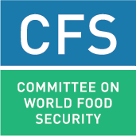
Template for submissions
(for individual experiences)

Experiences and good practices in the use and application of two selected CFS policy recommendations

Please use the template below to reflect your experience and good practices in applying (any) the following sets of policy recommendations:
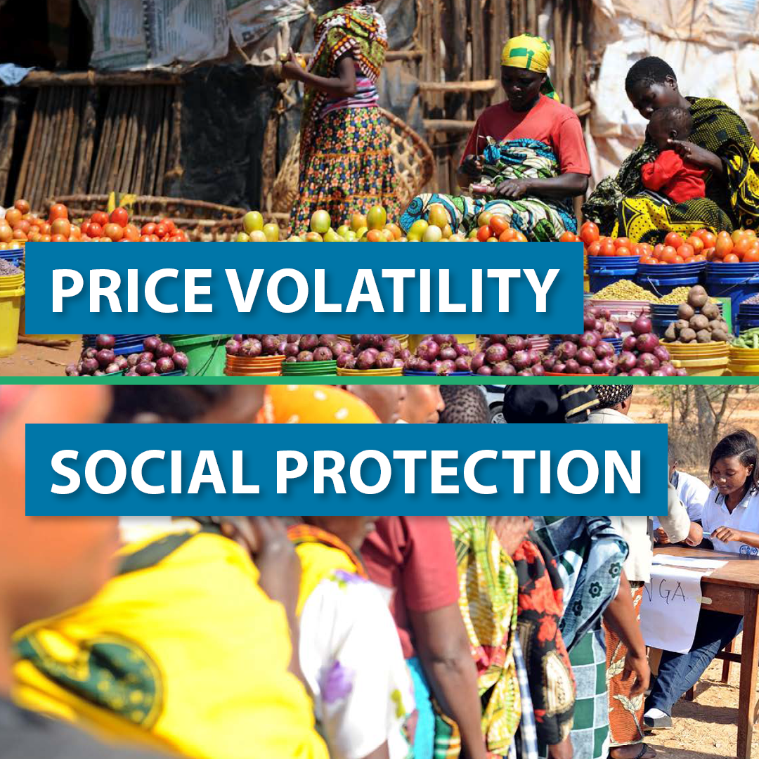
Set 1: Price Volatility and Food Security (endorsed in 2011, CFS 37)
Set 2: Social Protection for Food Security & Nutrition (endorsed in 2012, CFS 39)

Please note that if you wish to share more than one experience, a separate form should be used for each contribution. Submissions should be strictly limited to 1,000 Words.

The Call for Submissions is open until 3rd of May 2023.

Template for submissions
(for individual experiences)

Title of the experience
Geographical coverage | (e.g. national; regional if several countries of the same region; global if several countries in more than one region)
Country(ies) / Region(s) covered by the experience | (e.g. Malawi; Sahel: Great Lakes Region; or Kenya and Tanzania )
Contact person | Name: ……  Email address: …….
Affiliation | ☐ Government  ☐ UN organization  ☐ Civil Society / NGO  ☐ Private Sector  ☐ Academia  ☐ Donor  ☐ Other (specify) …………………………………………………………
- Which sets of policy recommendations has been relevant to the experience? (Choose all that apply) | ☐ Set 1: Price Volatility and Food Security  ☐ Set 2: Social Protection for Food Security & Nutrition  [if none of these two sets of policy recommendations has been used, please go directly to question xii]
- Which specific policy recommendation(s) of the Price Volatility and Social Protection has been used and found particularly relevant to the experience? | Price Volatility and Food Security  (Chose among the recommendations listed in the document, from a) to q) and explain why)  [e.g. Price volatility: recs: k) n) and q).]  Social Protection for Food Security & Nutrition  (Chose among the recommendations listed under A), B), C) and D) in the document and explain why)  [ e.g. Social Protection: recs: A 4); B 1)2)3): D 2)]
- How have these policy recommendations been used in your context?
Brief description of the experience

Who has been involved in the experience?  (Choose all that apply) | ☐ Government  ☐ UN organization  ☐ Civil Society / NGO  ☐ Private Sector  ☐ Academia  ☐ Donor  ☐ Other (specify) …………………………………………………………
How were the various stakeholders’ groups affected by food insecurity and malnutrition involved in the context of your experience? | (e.g. participation of civil society organizations (CSOs) representing food insecure and malnourished segments of the population in all training)
Main activities | (e.g. training of CSOs, lawyers, parliamentarians, government officials)
Timeframe | (e.g. started in February 2017 and on-going; started in July 2016 and completed in March 2018)
- Results obtained / expected  (for each, specify whether these outcomes are actual (as of when), or expected (and by when) | Results in the short term (qualitative and quantitative)  (In addition to providing a qualitative assessment, please indicate where feasible the number of people that have been directly involved in activities, e.g. six trainings involving a total of 250 people)
Results in the medium to long term (qualitative and quantitative)
(In addition to providing a qualitative assessment, including in addressing the underlying causes of food insecurity and malnutrition, please indicate where feasible the number of people that have been or are expected to be indirectly affected by activities, e.g. training leading to development of a local action plan expected to affect 1,000 people)
Most significant changes
(Please indicate the most significant changes that resulted from the activities as a result of the use and application of any of these two sets of policy recommendations)
- What were key catalysts that influenced the use of these CFS policy recommendations?
- What were the major constraints and challenges in the use of these CFS policy recommendations, and how were they addressed?
- What mechanisms have been developed to monitor the use of these policy recommendations?  (if any) | (Please indicate whether these mechanisms were developed by government or in the context of a project)
- Based on the experience presented, what good practices would you recommend for successful use or implementation of these CFS policy recommendations?

- Are there any concrete plans to further use these CFS policy recommendations?
- How could these policy recommendations be (further) used in the future for improving the food security and nutrition, advancing the progressive realization of the right to food, achieving SDGs?
- Link(s) to additional information
Question xii) below to be filled only if none of these two sets of policy recommendation has been used or applied.
xii) What are the reasons for not using these policy recommendations in your context so far? | e.g. absence of sufficient resources; lack of awareness etc;

