Online Expert Consultation on “Global Forest Resources Assessment: Towards FRA2025”
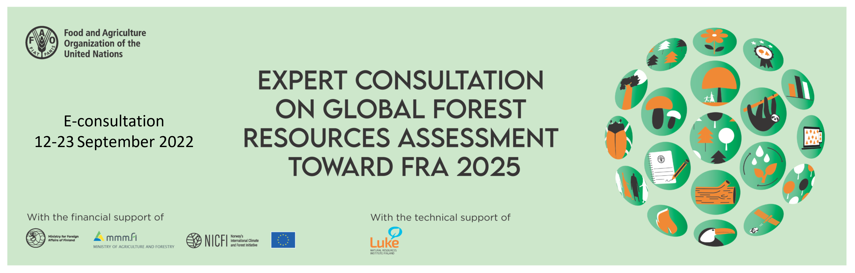
The Global Forest Resources Assessment programme (FRA) of the Food and Agriculture Organization of the United Nations (FAO) has received technical guidance and support from international specialists through expert consultations organized by FAO, with the support of the Government of Finland, at regular intervals over the last three decades. The first consultation was held in 1987 in Kotka, Finland, and the following took place in 1993, 1996, 2002 and 2006 in the same city (Kotka I-V). The most recent expert consultation was organized in 2017 in Joensuu, Finland.
FRA is a continuously improving process; each assessment is an upgrade of the former one as the information needs change, new and better data become available and new methods and technologies can be applied. Due to recent development in the international forest policy arena, such as the Paris Agreement, the Sustainable Development Goals (SDG) of Agenda 2030, the United Nations strategic plan for forests 2017-2030 (UNSPF) and the post-2020 biodiversity framework, there is a need for FRA to adapt in order to respond to the evolving information needs, both in terms of scope and reporting periodicity.
In this context, this online expert consultation is of paramount importance for providing relevant input and guidance for the next Global Forest Resources Assessment, FRA 2025.
The development objective of this online expert consultation is to contribute to progress towards sustainable forest management and better understanding of forest resources and their changes, through improved quality and frequency of information on forest and land use for better policy formulation, implementation and monitoring of the progress towards SDGs at national and international levels.
The immediate objectives of this online expert consultation are to:
- Provide recommendations on the scope of next global assessment including the country reporting process and the remote sensing component;
- Agree on standard definitions that will ensure increased consistency of reporting across countries;
- Enhance collaboration with other forest related reporting processes and organizations in order to reduce the reporting burden on countries and improve consistency of data across organizations/processes;
- Elaborate technical modalities for capacity building in developing countries;
- Discuss frequency of reporting on core variables and annual reporting on SDG indicators and other forest related indicators (e.g. for post-2020 biodiversity framework targets of CBD and targets of UNSPF); and
- Advice on priority thematic studies.
More specifically, experts are invited to provide comments and share their views on the five background papers (please click on the titles below to open the corresponding background paper webpage):
1. FRA 2025 –What has changed and why?
This background paper aims at documenting and explaining the rationale for the main proposed changes in the FRA 2025 specification/scope. The paper also includes a proposal for the re-introduction of a tiers classification system and a slightly modified section for the SDG indicators 15.1.1 and 15.2.1.
2. FRA 2025 country reporting process
This background paper provides an overview of the next reporting process, including the FRA 2025 timeline, the National correspondents’ network and capacity development plan, the review and validation of FRA 2025 Country reports and data analysis and proposals for the dissemination of results.
3. Proposal for more frequent voluntary reporting
This background paper discusses the issues related to the COFO request to FAO to develop a flexible FRA reporting process that allows voluntary updates of key indicators. It covers the scope of updates, process and timing, as well as implications for countries and the FRA secretariat. It presents a proposal for the implementation of voluntary updates for further discussion.
4. Improved reporting on primary forests – an update
This background paper summarizes the findings of the FRA special study on improving reporting on primary forest, which aims to enhance consistency, comparability, completeness and quality of data reported to FRA on primary forest. The background papers also includes proposed changes to the reporting on primary forest for FRA 2025.
5. FRA 2020 Remote Sensing Survey (RSS) and the way forward
This background paper describes the main performance indicators on the FRA 2020 RSS with a focus on the design aspect. The objective is to provide elements for discussion about the potential improvement of subsequent cycles of this exercise and how to make the estimates generated in this context useful for the FRA country reporting process.

The expert consultation is conducted in written form in the FAO Global Forum on Food Security and Nutrition (FSN Forum) as follows:
- From 12th to 18th of September: Participants can access the forum and provide comments to the background papers.
- From 19th to 23rd of September: The forum is be open for experts’ discussion.
Please visit each background paper webpage to find more information on how to access and review the papers and contribute to the discussion. Please note that this is an invitation only event, therefore participation to the discussion is restricted to invited experts.
We thank you in advance for your contribution and we look forward to a fruitful discussion!
Co-facilitators:
Paper #1 Örjan Jonsson, Anssi Pekkarinen, Monica Garzuglia, Chiara Patriarca
Paper #2 Monica Garzuglia, Anssi Pekkarinen, Chiara Patriarca
Paper #3 Lars Gunnar Marklund, Anssi Pekkarinen, Monica Garzuglia, Chiara Patriarca
Paper #4 Anne Branthomme, Javier DeLamo Rodriguez, Anssi Pekkarinen, Monica Garzuglia, Chiara Patriarca
Paper #5 Adolfo Kindgard, Anssi Pekkarinen, Monica Garzuglia, Chiara Patriarca

