Call for best practices in transforming food systems for affordable healthy diets and addressing key drivers of food insecurity and malnutrition

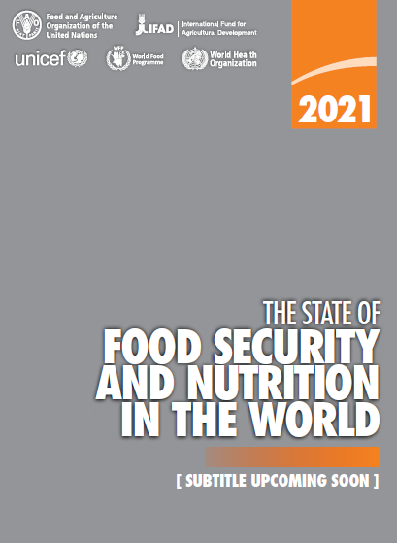
Template for submissions (maximum 2000 words in total)
The inter-Agency writing team of the 2021 edition of The State of Food Security and Nutrition in the World (SOFI) invites you to share illustrative examples of best practices and lessons learned in what it takes – in very practical and innovative ways – to transform food systems for better access to nutritious foods and affordable healthy diets.
When describing your example (case study) of a best practice and/or lessons learned, we invite you to demonstrate the following:

- A description of the food systems context (which food system component, rural versus urban, etc.).
- A multi-disciplinary approach guided by complementary policies, investments or interventions
- How the policies, investments or interventions address two or more key drivers of food insecurity and malnutrition (including: conflict, climate variability and extremes, economic slow-downs and downturns, poverty and inequality, economic and health implications of COVID-19).
- A clear description of how the best practices (and lessons learned) have led (or are expected to lead) to the transformation of food systems.
- How the transformative changes introduced helped raise the affordability of healthy diets (e.g. in raising people’s purchasing power and/or reducing the cost of nutritious foods).

The fields provided below will guide you through these key points. Please use this submission form to share your example of best practices and lessons learned in food systems transformation. You can upload the completed submission form to:
www.fao.org/fsnforum/activities/discussions/SOFI_transforming_food_systems or send it via email to fsn-moderator@fao.org.
Submissions are welcome in all six UN languages (English, French, Spanish, Russian, Arabic and Chinese). The call is open until 31 March 2021.
Proponent (name/institution)
M S Swaminathan Research Foundation

Title for the example (case study) presented
Farming System for Nutrition approach to address Malnutrition

Country context/location (national/sub-national; urban/rural)
South Asia/India/district; rural

Food Security and Nutrition (FSN) context and underlying drivers affecting FSN
(i.e. conflict, climate variability and extremes, economic slowdowns and downturns, COVID-19 or measures to contain it, and/or persistent poverty and inequality)
A large majority of the population in India is rural and dependent on agriculture and allied activities for their livelihood. About 86% of farmers are small and marginal farmers with less than 2 hectares of land and low agricultural productivity is an issue. Levels of malnutrition are also high in rural areas as shown by national surveys and diets are largely cereal dominated. The COVID-19 pandemic has reinforced the need for decentralized development approaches and local value chains.

Type of food system / key characteristics of the food system component considered (please describe the challenges, inter-linkages and complementarities among the food system’s components)
Farming System for Nutrition (FSN) is an approach conceived by Professor M S Swaminathan, the first World Food Prize laureate and first chairperson of the Steering Committee of the High Level Panel of Experts on Food Security and Nutrition (HLPE) of the Committee on World Food Security (CFS). FSN propounds mainstreaming the nutrition dimension in the design of the farming system. It is a location specific design that takes into account local natural resource availability, nutrition status of the population and extant food system practices. A study on feasibility of the FSN approach was undertaken by the M S Swaminathan Research Foundation in two agro-ecologically different locations in India, Wardha district in the state of Maharashtra and Koraput district in the state of Odisha from 2013 to 2017. The agriculture practiced in Koraput is subsistence type and dominated by paddy, followed by finger millet. In Wardha, it is largely commercial agriculture dominated by cotton and soybean. The baseline survey revealed high levels of undernutrition, cereal dominated diets and low level of nutrition awareness (Bhaskar et al. 2017).
The key gaps identified were:
- Less area under millet cultivation and low productivity of the crop: Tribal households in Koraput traditionally consume finger millet on a regular basis but were found to be sourcing it from the market. In Wardha, the land under sorghum cultivation was found to have been replaced by commercial crops.
- Low availability of pulses: There was no pulse crop during the kharif season in Koraput and productivity was low during rabi. In Wardha, productivity was low and there was limited diversity. The consumption of pulses was below recommended levels in both locations. There is hardly any processing at the village level in both locations.
- Low cultivation and consumption of all groups of vegetables and fruits
- Low consumption of animal proteins: This was below recommended levels with consumption largely during special occasions and festivals.
- Knowledge gap on nutrition and healthy foods
The FSN design developed in consultation with the community, focused on increasing the availability of nutrient dense crops, viz. millets and pulses, promoting nutrition garden of fruits and vegetables, increasing access to animal source foods, viz. fishery in Koraput and poultry in Wardha, accompanied by initiatives to increase the level of nutrition awareness.
Ref: Bhaskar AVV, Nithya DJ, Raju S and Bhavani RV. 2017. Establishing integrated agriculture-nutrition programmes to diversify household food and diets in rural India. Food Security. Food Sec. (2017) 9:981–999 https://link.springer.com/article/10.1007/s12571-017-0721-z

Combined goals of the policies, investments and/or interventions described (a, b and/or c)
- Strengthened resilience to external shocks and stresses (e.g. climate, conflict, economic, COVID-19)
- Address underlying structural causes of hunger and malnutrition (e.g. poverty, inequality)
- Sustainably transforming food systems to lower the cost of nutritious foods and/or improve affordability of healthy diets
FSN interventions included:
- Crop intervention: Enhancing production and productivity of nutrient-dense crops through increase in area, varietal substitution, and crop diversification
- Nutri-garden: Increase the availability of vegetables and fruits across all seasons
- Animal Husbandry: Improve the household consumption of animal foods
- Nutrition Awareness
The interventions focused on improving the dietary diversity of the population as a first step to better nutrition outcomes. The sustainability of interventions required demonstration of economic viability, for adoption by the farmers. Improved agriculture practices and improved variety of seeds led to higher returns compared to what the farmers were realizing (Pradhan et al. 2019).
The goal was to strengthen the resilience of the population by making agriculture viable and increasing local availability of nutri-dense foods to improve household dietary diversity.

Ref: Pradhan, A., Akshaya Kumar Panda and R.V.Bhavani. 2019. Finger millet in tribal farming systems contributes to increased availability of nutritious food at household level: Insights from India. Agricultural Research: doi: 10.1007/s40003-018-0395-6

Key characteristics of supporting policies, investments and/or interventions
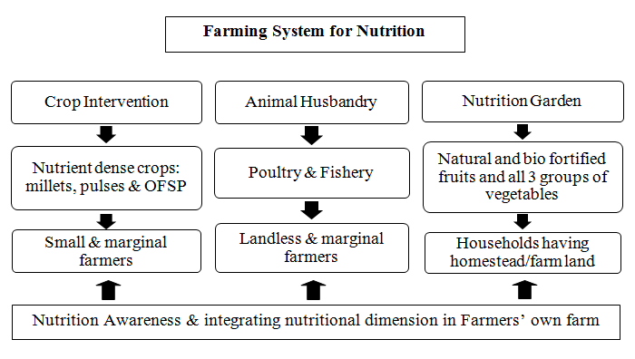
The figure gives a schematic presentation of the interventions under the FSN approach. Linkages were developed with the district agriculture and animal husbandry departments for necessary support in trainings and provision of inputs. The local agriculture and veterinary universities were also engaged with.

Key actors and stakeholders involved in the development and implementation of the example provided (please also describe to what extent a multi-stakeholder and participatory approach has been adopted)
Key Actors and stakeholders:
- Community of farm men and women in the project villages
- District level Department of Agriculture, Department of Animal Husbandry, Integrated Child Development Services (ICDS)
- Agriculture University, Veterinary University, ICAR institutes in the region for technical guidance
- Private sector – Nirmal seeds for supply of quality seeds of pulse varieties
- Local civil society
- State level policy makers
- Project Implementation team of scientists and field implementation personnel
The study followed a participatory approach right from the beginning with the population in the project study villages being oriented on the opportunity to leverage agriculture for nutrition in the context of their prevailing nutrition status. On-farm demonstrations were undertaken in the initial years for farmers to see for themselves the returns from what they were practicing and the interventions promoted. The results were shared with a technical platform comprising scientists and researchers and stakeholder platform of local NGOs, progressive farmers, and district and block level government officials for suggestions. Men and women were selected from the community to undergo training to be Community Hunger Fighters. They were trained on basics of nutrition and linking agriculture to nutrition. Awareness was created on government entitlements related to agriculture, food and nutrition and how to access them.

Are there important linkages of interventions in the food system with other systems? (e.g. the health systems, environmental systems and/or social protection systems)
Nutrition gardens of fruits and vegetables were promoted in the village schools and ICDS centres, with the objective of creating greater awareness as well as making fresh produce available for the midday meal in these institutions. Village level training programmes were conducted in collaboration with the ICDS centre workers, village health worker and school teachers.
The FSN design was adapted to the local environment and natural resource availability with focus being brought on nutrition.
Awareness was generated on extant government schemes for agriculture (e.g. availability of seeds, irrigation schemes, other input support), food security entitlements (e.g. access to the public distribution system, supplementary nutrition for children and pregnant and lactating women under the supplementary nutrition programme of the ICDS).

Highlight key innovative and/or transformative changes in the specific food system as a result of the policies, investments and/or actions leading to improved FSN (please note that “transformative change” refers to innovative, pro-active changes away from “business as usual”)
Analysis of the endline survey in late 2017 following three years of intervention showed increased production diversity and availability of millets, pulses; increased number of household nutrition gardens and availability of vegetables, improved frequency and quantity of consumption of all food groups and improved household dietary diversity (Pradhan et al. 2021).

Ref: Pradhan A, S. Raju, D. J. Nithya, Panda AK, Wagh RD, Maske MR and Bhavani RV (2021) Farming System for Nutrition-a pathway to dietary diversity: Evidence from India. PLoS ONE 16(3): e0248698.
https://doi.org/10.1371/journal.pone.0248698

Highlight challenges faced (any sort of trade-offs, and how these were managed) and/or efficiencies gained as a result of the best practice presented (e.g. win-win situations)
Use of improved varieties of seeds and improved agriculture practices of the nutri-dense crops promoted led to better yield and returns
Nutrition gardens of vegetables led to increased consumption at household level
Men and women from the community started emerging as spokespersons and there was uptake in neighboring villages
Uptake of the FSN approach beyond study villages was documented: 25 villages in Wardha and 18 more villages in Koraput, reaching out to more households.
http://59.160.153.187/blog/taking-farming-system-nutrition-approach-scale
Challenges:
Water scarcity during summer months is a challenge to maintain nutrition gardens
Lack of village level processing for millets and pulses was a challenge. Cluster level processing mills managed by farmer groups/self help group of women were promoted in Odisha.
Focus of agriculture officials in on increasing production and productivity. The nutrition focus is missing.

Key lessons that can be learned from your case (both positive and negative) and whether these could be applicable in other contexts with similar characteristics
A farming system for nutrition approach can enable small holder farm households to improve their nutrition security.
Nutrition Awareness across the board has to be inbuilt in the approach.
The approach can be adapted to other contexts where the population is primarily dependent on agriculture

Summary of key messages
Location specific Farming System for Nutrition approach is an example of nutrition-sensitive agriculture to address malnutrition in communities dependent on agriculture.
Mainstreaming the nutrition dimension in the farming system will help improve household dietary diversity of small farm households.
The Farming System for Nutrition design has to be adapted to local conditions and natural resource availability.
Location specific FSN models will enable greater uptake of nutrition-sensitive agriculture and sustainable local food systems

The inter-Agency SOFI writing team consists of technical experts from FAO, IFAD, UNICEF, WHO and WFP.
Food systems are made up of everything, and everybody involved in producing, storing, packing, processing, distributing, consuming, and disposing of food, including the social, political, economic, and environmental systems which influence and are influenced by those activities (Parsons, K. & Hawkes, C., 2018). See also the food systems diagram in: CFS High Level Panel of Experts (HLPE), 2020. “Food Security and Nutrition: Building A Global Narrative Towards 2030”, HLPE Report 15.

